Salesforce Configuration Model-1 Assignment

Changes to be done before starting the assignment below:

- Instead of Roll-up Summary type for below fields use number type on Project :

Estimated Hours : Rollup of all the estimated hours on each task related to project
Billable Hours : Rollup of all the billable hours on each task related to project
Non-Billable Hours : Rollup of all the non-billable hours on each task related to project
[delete the roll up summary]

2. Delete the custom object Project Task

Do the following things in the SF Org:

- Change the page layouts for User, Project, Project Member, and weekly snapshot to include different fields of your choice.
Projects
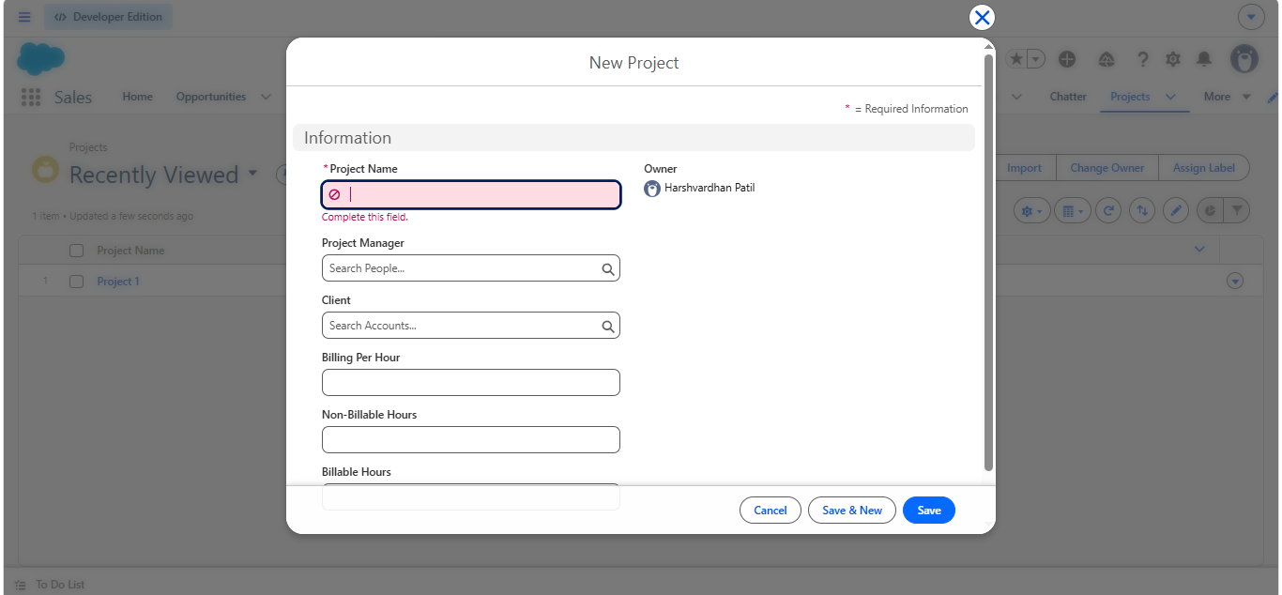
Project Members
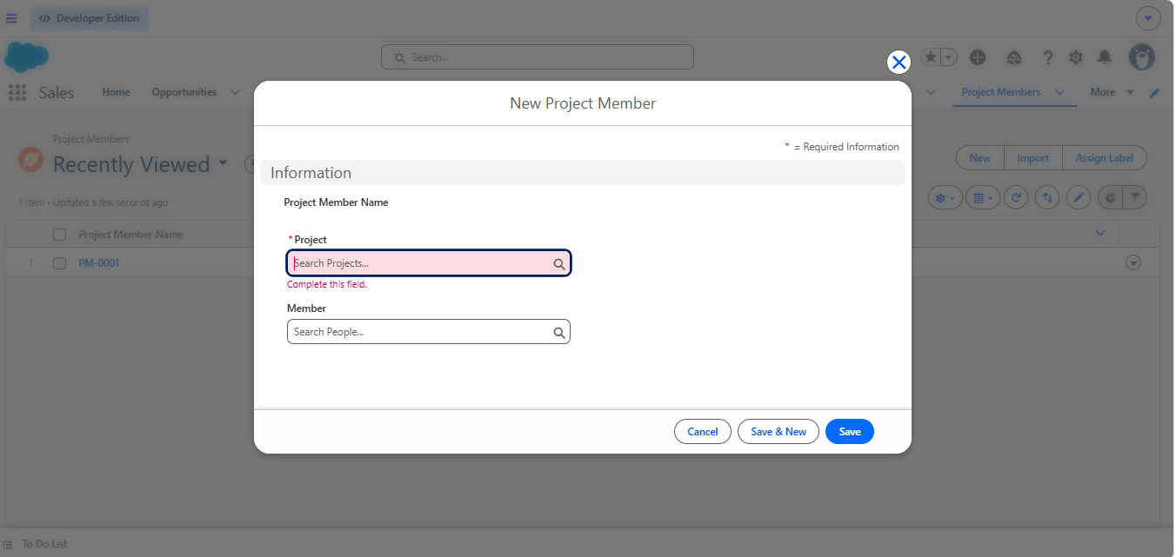
Weekly snapshot
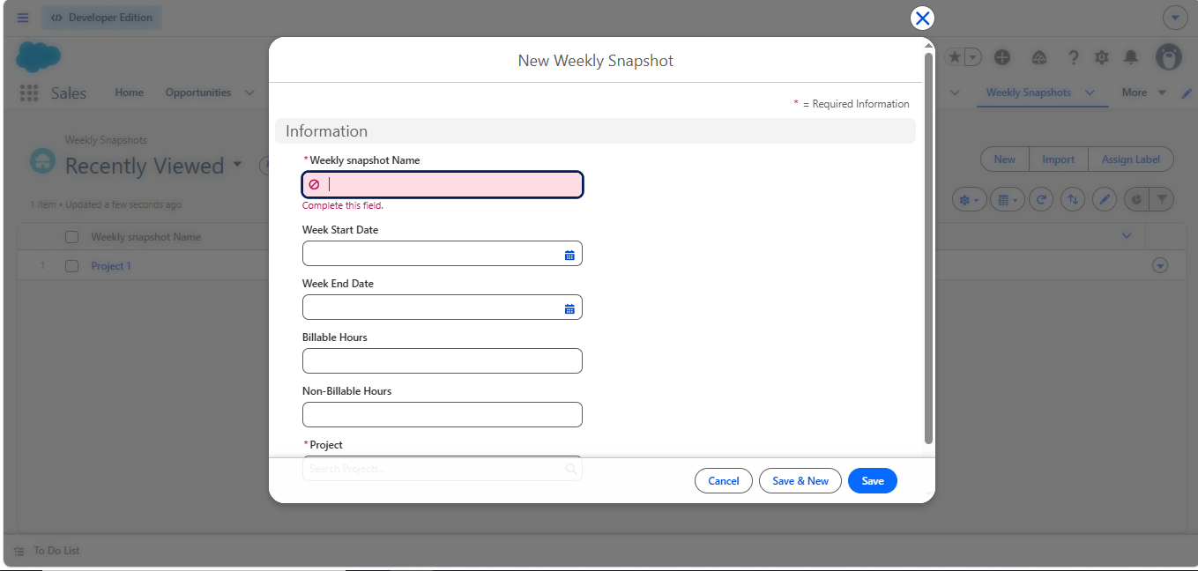
- Implement different page layouts and record types for Project Task object so that whenever they are creating a new record in ‘Case’ they should be able to see ‘Bug’ and ‘Story’ as record types.

Bug page layout fields:

Project : Lookup (Project)
Estimated Hours :
Billable Hours :
Non-Billable Hours :
Subject : (Standard Subject field)Task Subject
Assigned To: (Standard Owner Field)
Acceptance Criteria : Rich Text Area (Custom Field)
Status (Picklist - Rejected, Deferred, New, In Progress, QA, Completed)
Assigned Date : DateTime
Due Date : DateTime
Completed Date : DateTime
Report To (Lookup to User)
Type : (Picklist - Story/Bug)
Environment: Sandbox/Production
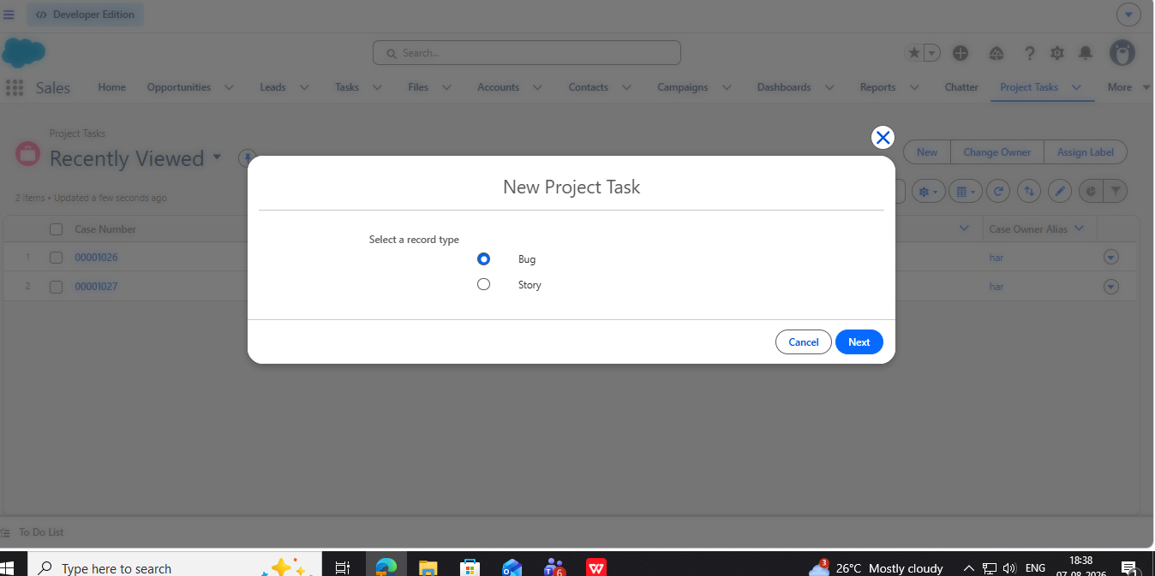

Story page layout fields:

All the fields mentioned in Bug page layout except Environment and including:
User Story: Description
Story Point(picklist): 2,4,8,12,16
Status (Picklist - New, In Progress, QA, Completed)
- Implement a solution that whenever a project task is created it is assigned to the appropriate users based on task type(Configuration, Development, Data Migration, Deployment, Testing)
Migration: Migration Team Queue
Configuration: Configuration User Queue
Development: Configuration Developer(User)
Deployment: Deployment Queue
Testing: Testing Team(Queue)

Run it via Email-To-Case and Web-to-Case.

- Create a Global Action apart from the one existing in the org.
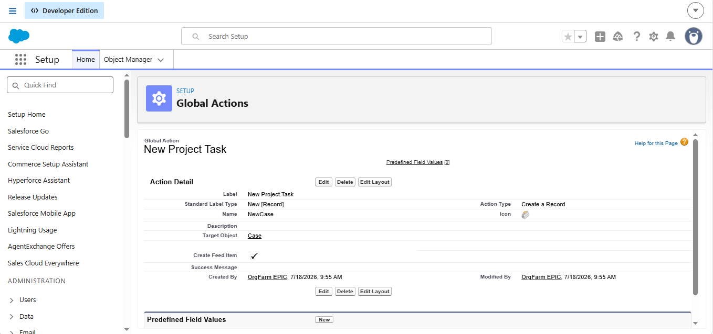
- Implement below validation rules:
a) Ensure that the first letter of Employee First Name and Last Name are in capitals.
b)In Weekly Snapshot object Start date and End date should not be blank and ensure that Start Date and End Date should not be Sunday and Saturday.
c)If Task status is “In progress” it should not be changed to “New”;
d) On student course object, create a text field(optional) called as External Course Id. When ‘External Course Id’ is not blank, ensure that you have a matching course record (Student Course.External Course Id = Course.External Id)
NOTE: Student Course is junction object between Student and Course. Do not consider field called as Course on Student Course object for this requirement. This is not a end to end solution.

6. Create two page layouts and assign them to two different profiles. Page Layout Names: Manager and Employee.

Employee Page Layout: It should not have Billing per hour, Allocated Hours,
Manager Page Layout: It should have all the fields visible.
